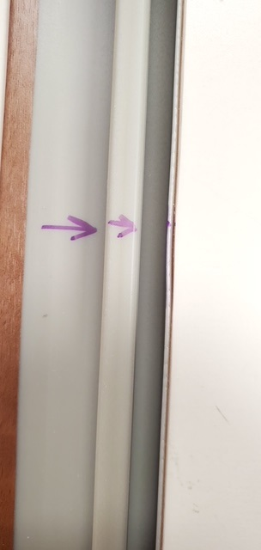

QUALITY ALERT

Customer: ChamClad Date: May 27, 2022
Die: 15744 Color: Any
Type of Complaint: ChamClad REJECT Customer NCR:

Description: ChamClad REJECT – the material has the wall COLLAPSE on/off.

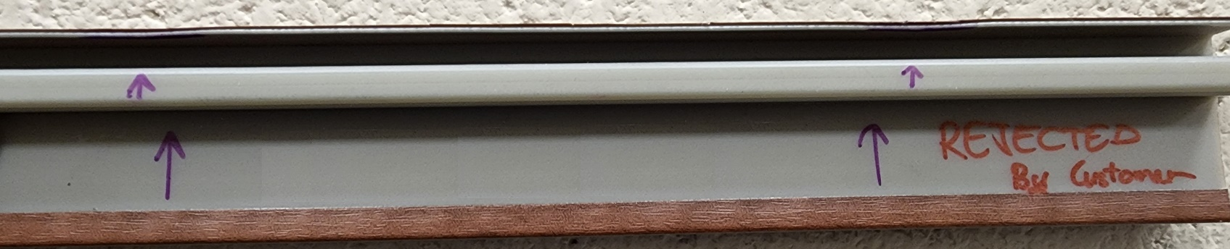

PLEASE CHECK CAREFULLY THE PIECE TO AVOID THIS ISSUE

BY SIGNING BELOW, YOU ACKNOWLEDGE THE PROBLEM ABOVE AND AGREE TO MONITOR THIS ISSUE IN FUTURE PRODUCTION RUNS.
DAY SHIFT |  | AFTERNOON SHIFT |  | NIGHT SHIFT
NAME | SIGNATURE | NAME | SIGNATURE | NAME | SIGNATURE

